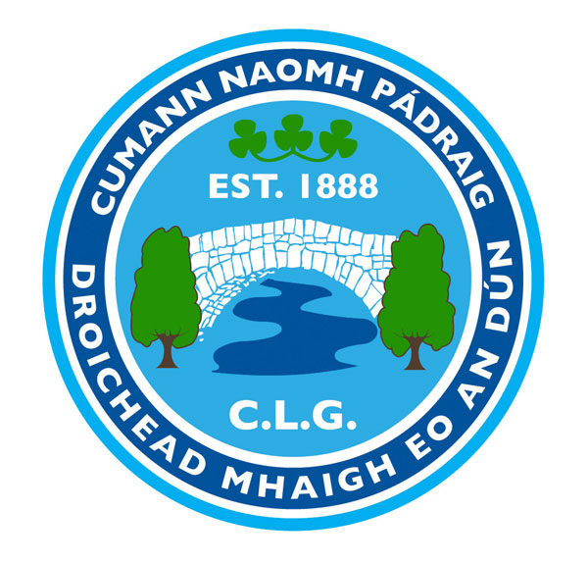

AGM NOMINATION FORM 2016

Mayobridge GAC Club’s Annual General Meeting will be held in the Clubrooms on Monday 12th December 2016 at 7.15pm.

All fully paid members are entitled to nominate (nominee must be asked), and vote. All nomination papers must be signed by the member submitting the nominations.
Nominations, motions and Recommendations must be returned to Michael Toner (Club Secretary) on or before Monday 5th December 2016 – returns may be sent by email to secretary.mayobridge.down@gaa.ie.

Only fully paid up members can nominate, be nominated and vote

Positions for election: Your Nomination

Chairperson……………………………………………………………………………

Vice Chairperson……………………………………………………………………...

Secretary……………………………………………………………………………….

Assistant Secretary……………………………………………………………………

Treasurer………………………………………………………………………………

Assistant Treasurer…………………………………………………………………..

Registrar……………………………………………………………………………….

Delegate to County Board……………………………………………………………

Child Protection Officer………………………& Deputy…………………………..

P.R.O……………………………………………………………………………………

Children’s Officer……………………………………………………….....................

Health & Well-Being Officer........................................................................................

Coaching Officer………………………………………………………………………

Cultural/Language & Community Officer………………………………………...

Players’ Representative (Male)………………………………………………………

Players’ Representative (Female)……………………………………………………

School Liaison Officer………………………………………………………………...

Additional Officers……………………………………………………………………

Signed………………………………Print Name……………………..Date…….....

NOMINATIONS & RECOMMENDATIONS OVERLEAF PLEASE

